GROUP MEMBERS

PROJECT
REPORT

[Online Furniture Shop]

I. Summary 2
II. NEED FOR IDEA 2
III. FUNCTIONALITY 2
V. AT LAST 2

- Summary
Our project is abut online furniture shop. We are providing online furniture shopping service, where customers can buy online furntures.Furniture now a days is an essential part of modern houses, it is requirement as well as needed for decoration.
Our project will show customers our products from which they can select any product and then we will take their information and address where to deliver their order. They will take print of bill.
This project help those customer how are busy in their workplace, they can order online and buy good quality furniture. we offer good quality furniture

Why we chose this idea?
Because behind every idea is to solve the problems of the people.
We use this idea of online furniture shop,
In order to keep record of our online selling and in order to keep the address of our customer so in future if any issue occur we help theme. People can save their time
By visiting our site they will get their required product (furniture), without wasting their time searching for their required furniture item. Our main aim is to help people.

Functionality:

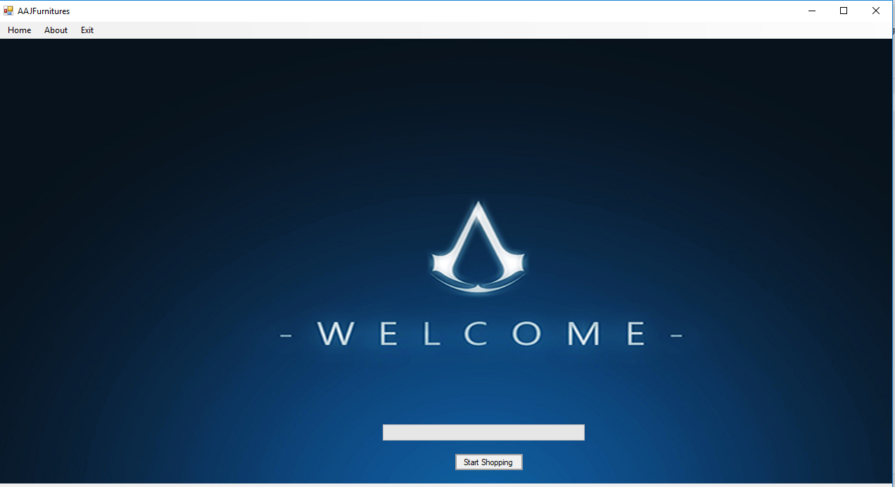

This is our homepage when a user runs our application on his pc this page will show up , WELCOMING him from our side. Top of every form there is menu bar from which user can go to some of our pages directly. He can also see about us, and can also give feedback which will be submitted in our database and we can view it.
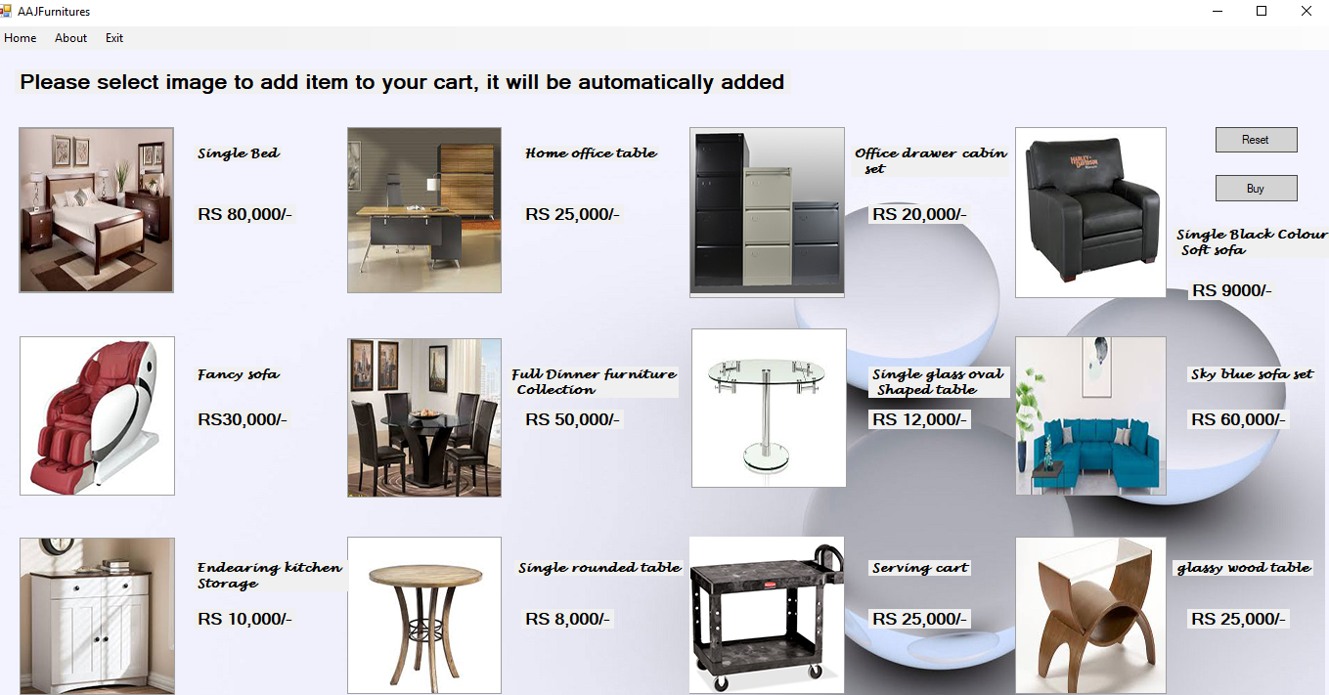

Here is our page which will open when a customer clicks on Shop button this will open. Here he will click on product image which he likes and it will be added to his cart. When he clicks on RESET button all products added to his cart will be removed. When he clicks on BUY button products will be added and he will be prompted to to next page where he will prompted to give his personal info.

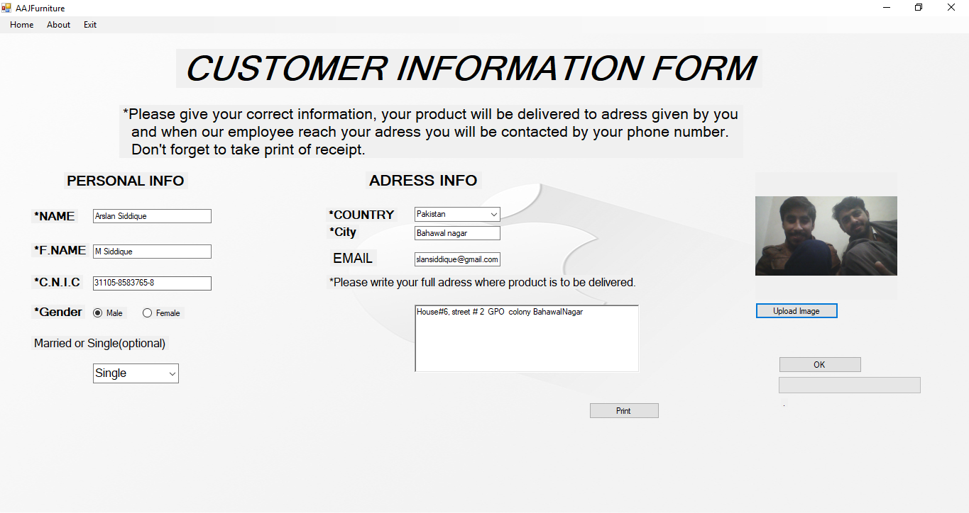

Here he will give his personal info picture,
After entering all data he will needed to press ok then his data will go in our database, then he will be needed to press Print button where his bill will be printed.
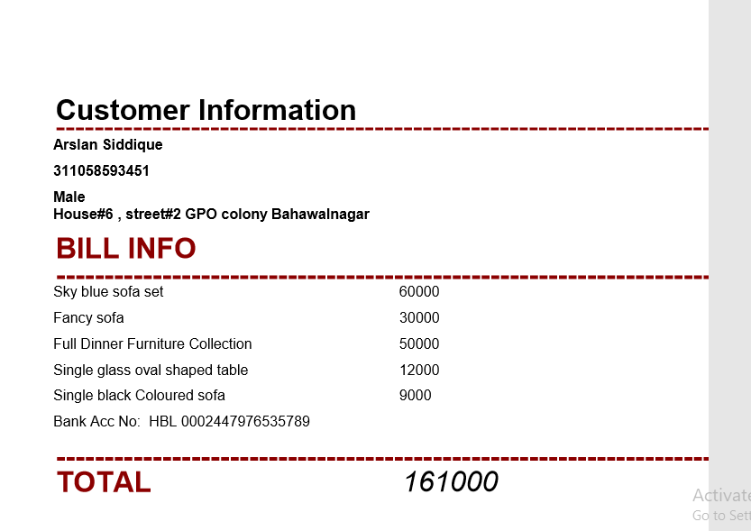
Above picture is of bill of a customer.
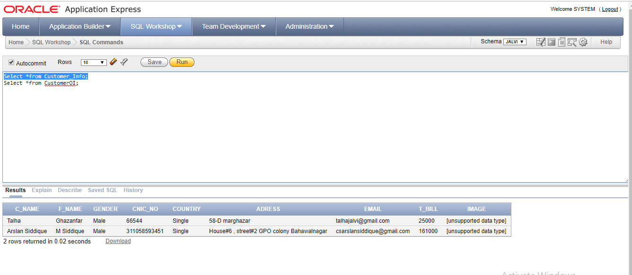
Above are customer orders in our database.
Above is picture of customers data in our database.
At Last:
Our project will help people who cannot go to shops to buy and select their needed furniture.
And this will also help people as if we improve our application a customer will have many different products to chose and will also do shopping from any country.

